**Online Pet Care**

**Abstract**

Attachment, a normal behavior among social animals, is quite significant since owners worry about their pets and take care of them because of this affective connection. There are not enough research studies that focus on attachment between owners and their pets. The general objective of this study was to identify attachment behaviors, directed toward their owners, in pets of different types, age groups, and sexes in an experimental situation. Pets are also an important parts of human life, The care and love pets like human. The thinks want to do in every pets are different. If some one buy a new pets and how don’t know about the caring of the pets, In the Situation our application help to know about the pets and the whole details of the pets. The aim of the application is to share the information about their pets and ask the opinion about their pets to the experts.

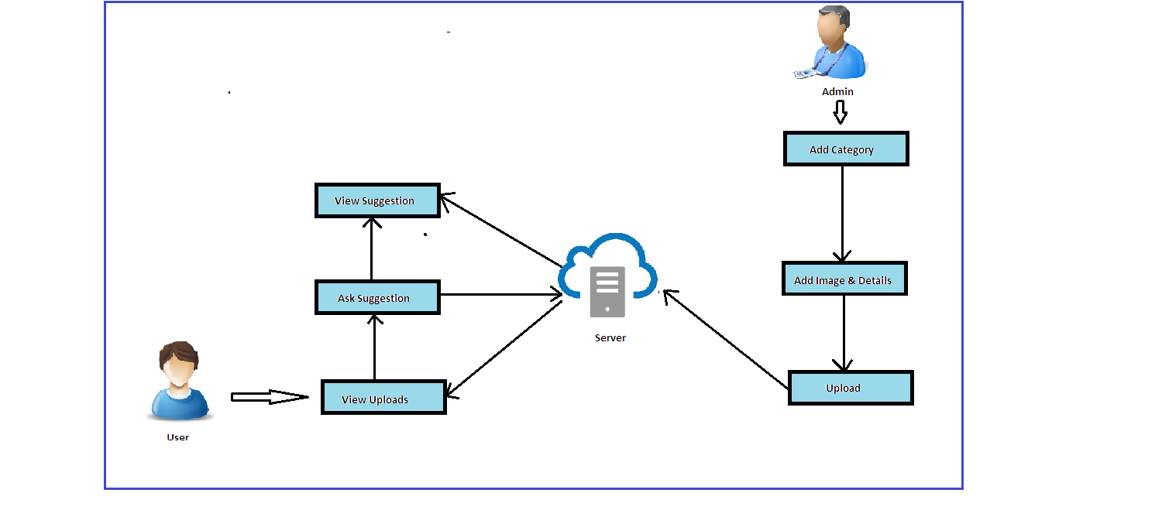

**Existing System**

There is no such existing system for pet care. Pets are also have an important part of humans life. The Main aim of application is to connect the all pet owners together, collect and share their experiences. The shared experience will be useful to some one who is new in pet care.

**Proposed System**

The Main aim of application is to connect the all pet owners together, collect and share their experiences. The shared experience will be useful to some one who is new in pet care. The Application contain a admin and a user. Admin is the authority to collect and share the usefull information to the user. The uploaded information will be stored in the cloud. And the user will view the admin uploaded information in mobile. The Admin uses a PHP application and the user side use a mobile application for collecting and view information’s from the cloud. Users can also upload images of their pets.

**Conclusions**

Many studies utilizing dogs, cats, birds, fish, and robotic simulations of animals have tried to ascertain the health benefits of pet ownership or animal-assisted therapy in the elderlyPets may also have harms: they may be expensive to care for, and their owners are more likely to fall. To avoid these situation we create an application that help to connect all pet owners. This Application will help to some one who is new in pet care.